MedMinder Mobile Application User Guide
Table of Contents
Download 1
Registration 1
Managing Notifications 4
Push Notifications 4
Caregiver Notifications 5
Managing Patients 7
Adding Patients 7
Viewing and Editing Patients 8
Managing Caregivers 9
Adding Caregivers 9
Transferring Care 10
Self-Care 10
Managing Medications 10
Managing Dosage Schedule 12
Device Settings 14
Registering a Device 14
Deregistering a Device 14
Other Settings 15
Photo Gallery 15
Custom Greetings 16
Volume 16
Pin Code 16
Locking 16

Download
To access MMConnect via mobile device, scan the appropriate QR code below and download the app.

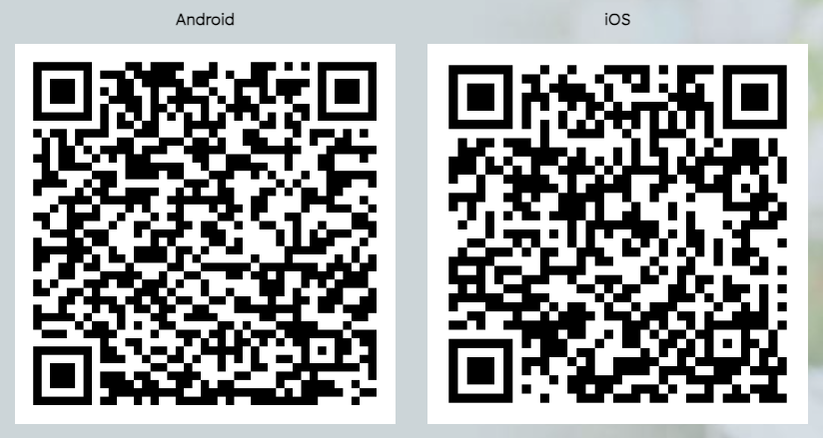

Registration
Open the downloaded mobile application and click the “Register” button.

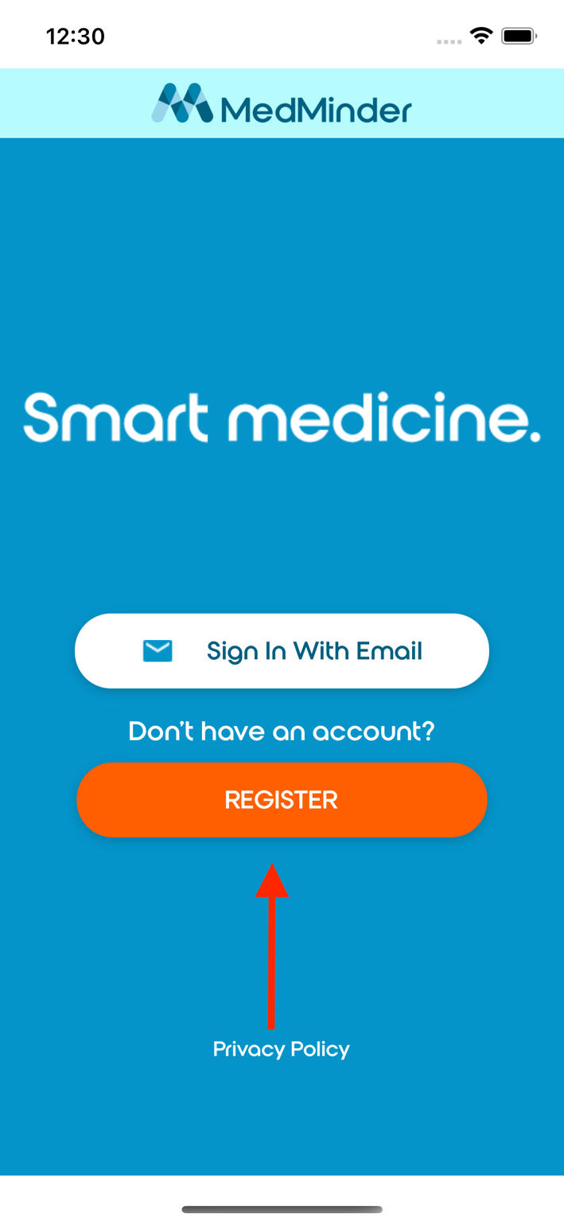

Begin the registration process by providing a valid email and secure password. Once submitted, MedMinder will send a confirmation email to the email provided. The confirmation email will contain a link to confirm the email. This step can be done on a web browser or through the mobile application.

Once the email is confirmed. Click the “Sign In With Email” button (above the “Registration” button). Enter the email and password provided earlier.

Upon logging in for the first time, the user is presented with the option of registering as a Patient or Caregiver.

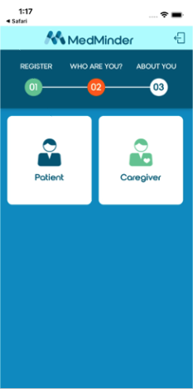

Complete the user form, ensuring to provide information in required fields marked with an asterisk.

If registering as a Caregiver, the user will be presented with the option of creating a new patient. Refer to Managing Patients for more information related to creating a new patient.

Managing Notifications

Push Notifications
Upon logging into the mobile application for the first time, the user will be asked to allow the mobile application to use Push Notifications. It is important that this permission is allowed for push notifications to work.

If the push notification permission was denied, and the user wants to allow notifications at a later point, the permission can be changed within the System Settings of the mobile phone.

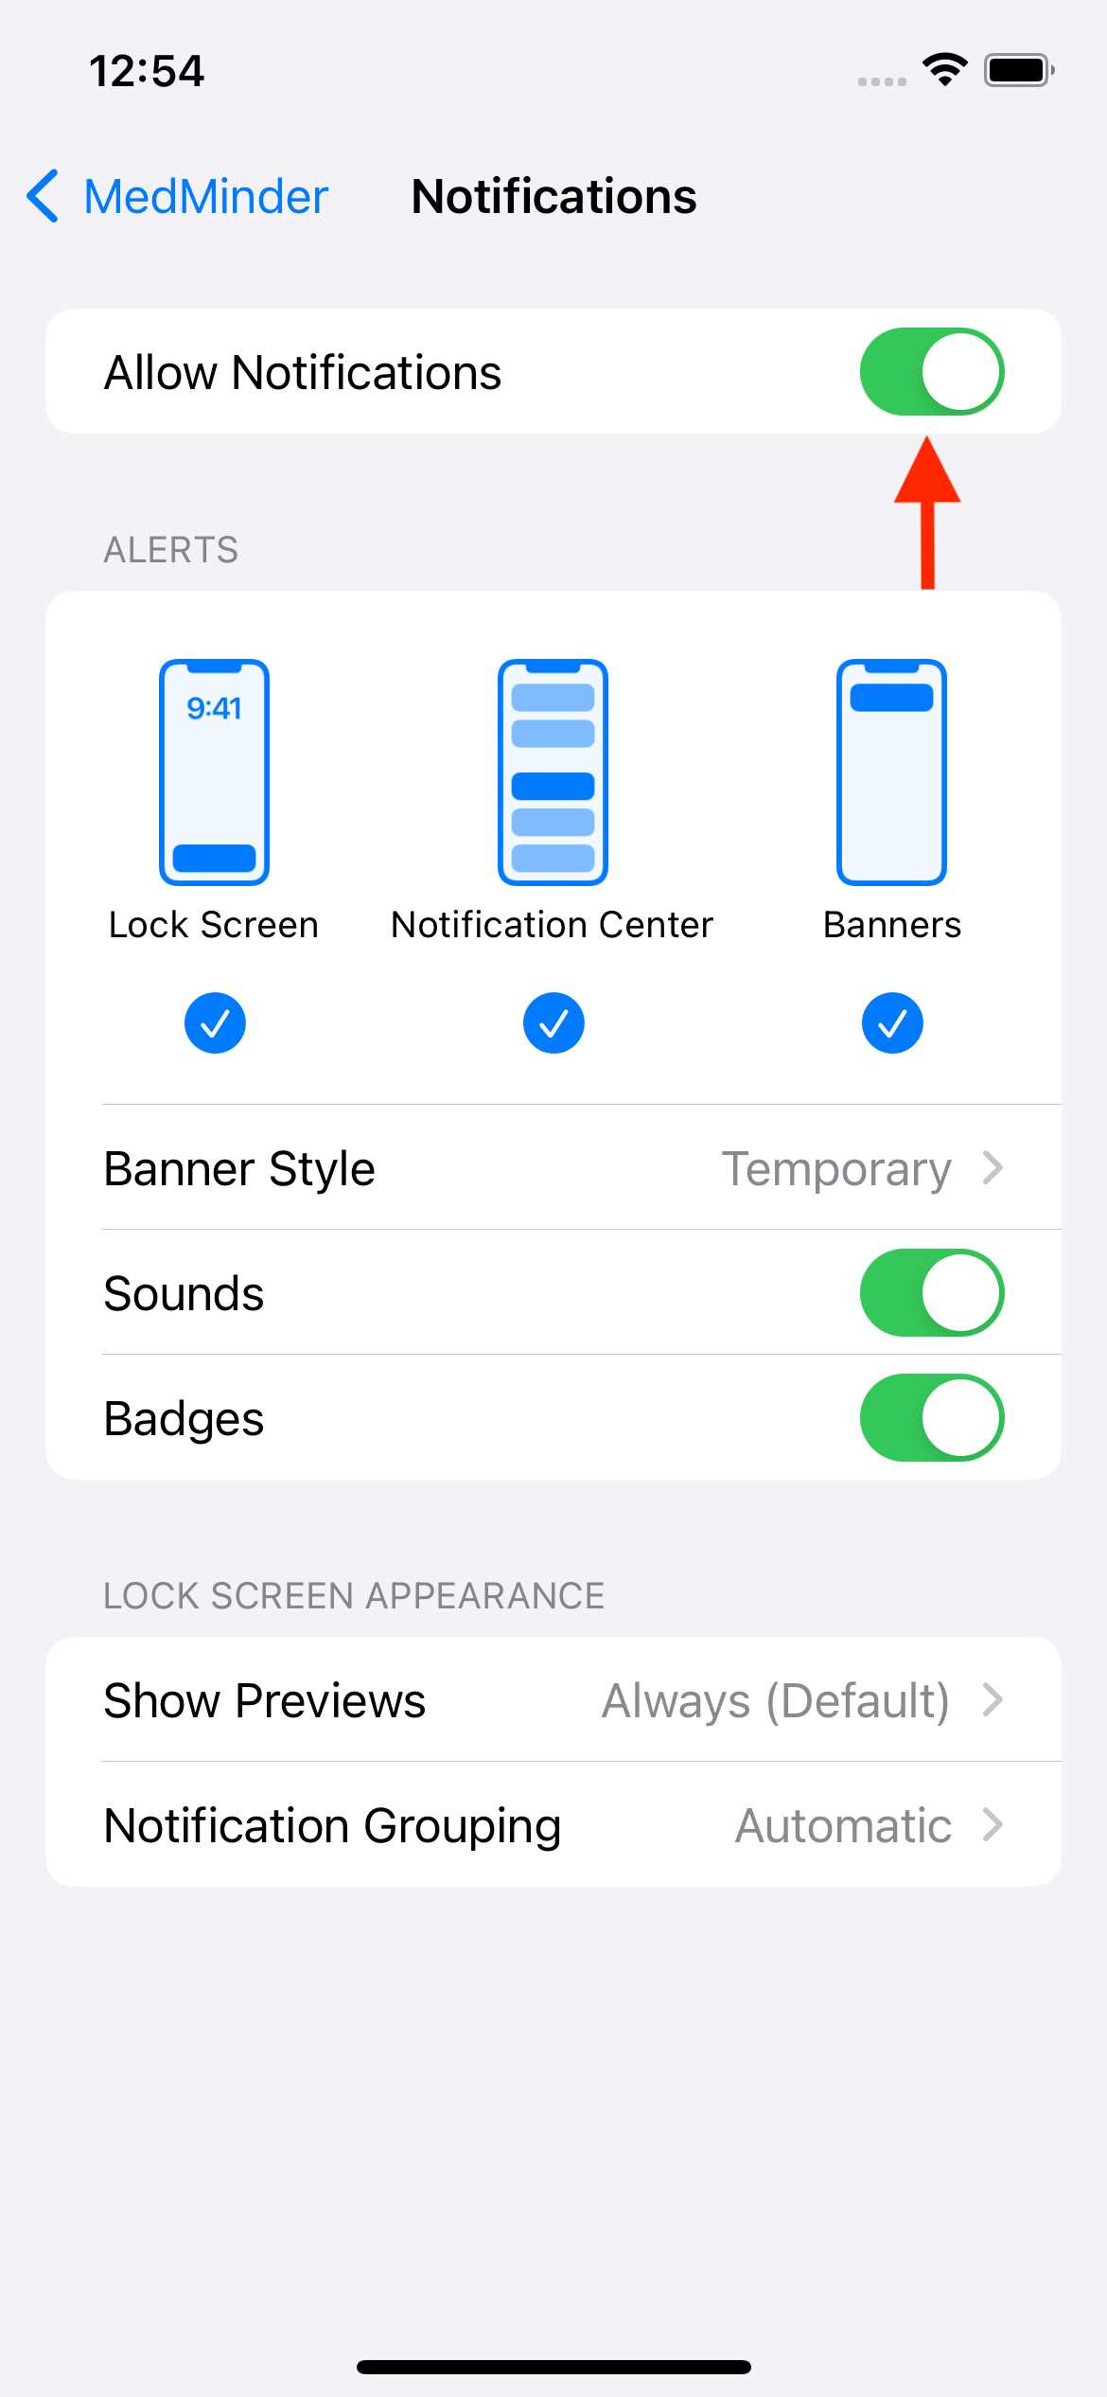

In-app notification settings can be access via the hamburger menu of the Patient List page.

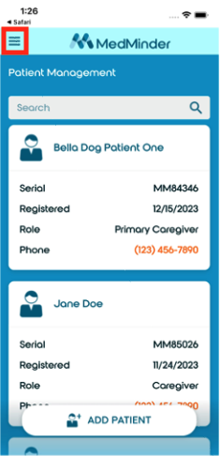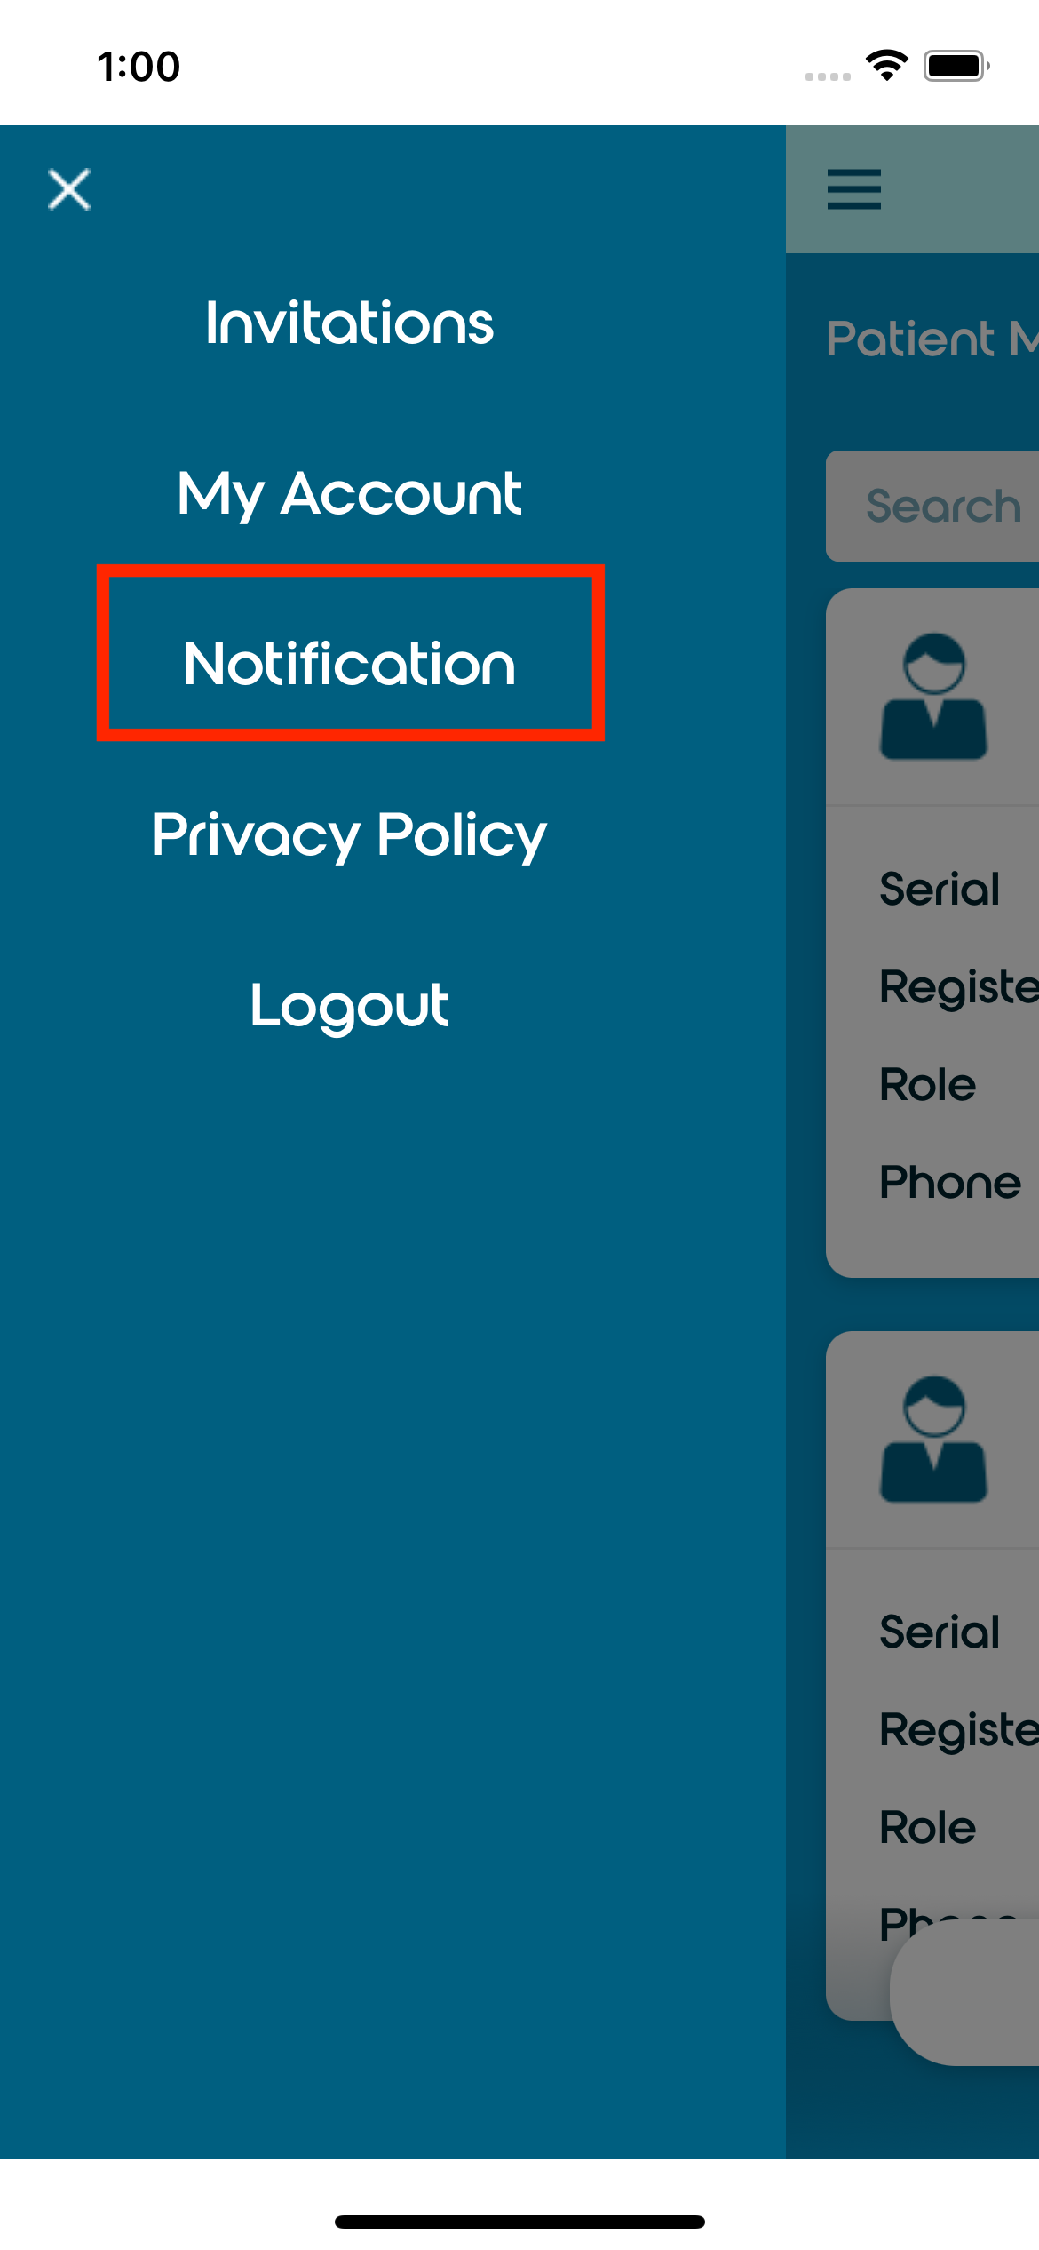

Caregiver Notifications
To configure caregiver notifications, select the patient from the Patients List page and click the “People” tab on the bottom left of the screen.
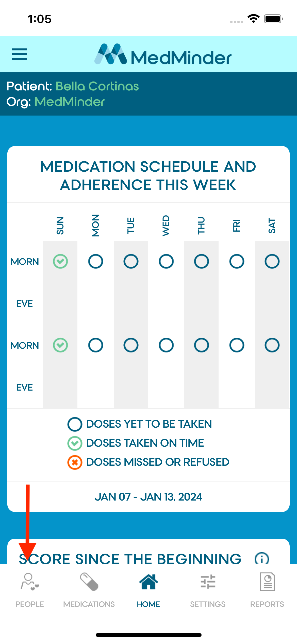

Underneath the Caregivers section, click “Edit” underneath the Caregiver card. If the user is editing their own notification settings, click the “Notifications” tab. For self-care patients, notification preferences can be configured through the “Edit” button nested within the card under the “Patient” section.

The user will be presented with all caregiver notifications. After confirming notification preferences, scroll to the bottom of the page and click the “Save” button.

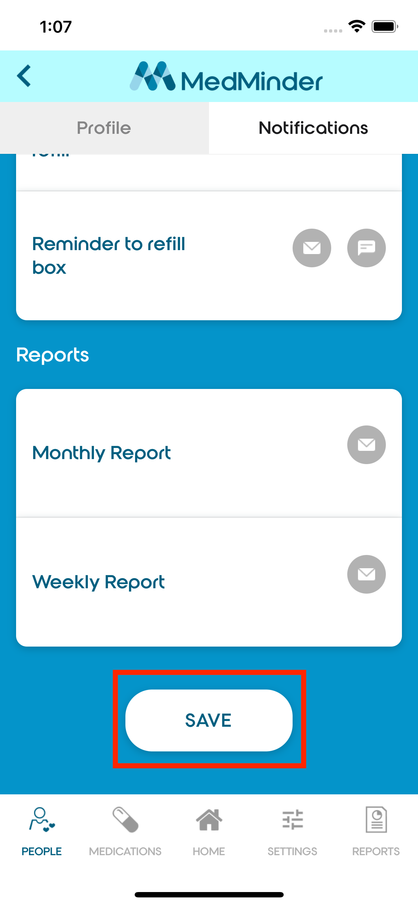

Managing Patients

Adding Patients
To add a new patient, click the “Add Patient” button within the Patient List page.

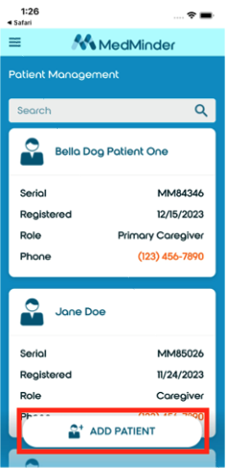

Fill out the required patient information. Required fields are marked with an asterisk (*). After submitting the patient form, the user will be taken back to the Patient List page where the newly created patient profile can be found.

Viewing and Editing Patients
Select the patient from the Patient List page. There is a patient card at the top of the People’s tab. Click “Edit” or “View” within the patient card to edit or view the patient profile. The user will see either option depending on whether they are the primary caregiver.

Managing Caregivers

Adding Caregivers
To add a Caregiver, select the patient from the Patient List page and navigate to the People tab in the bottom left of the screen. Click “Add Caregiver”, then click “Add Existing User” if the caregiver already has a MedMinder account. If the caregiver does not have a MedMinder account, click “Add New Caregiver” and fill out the required information.

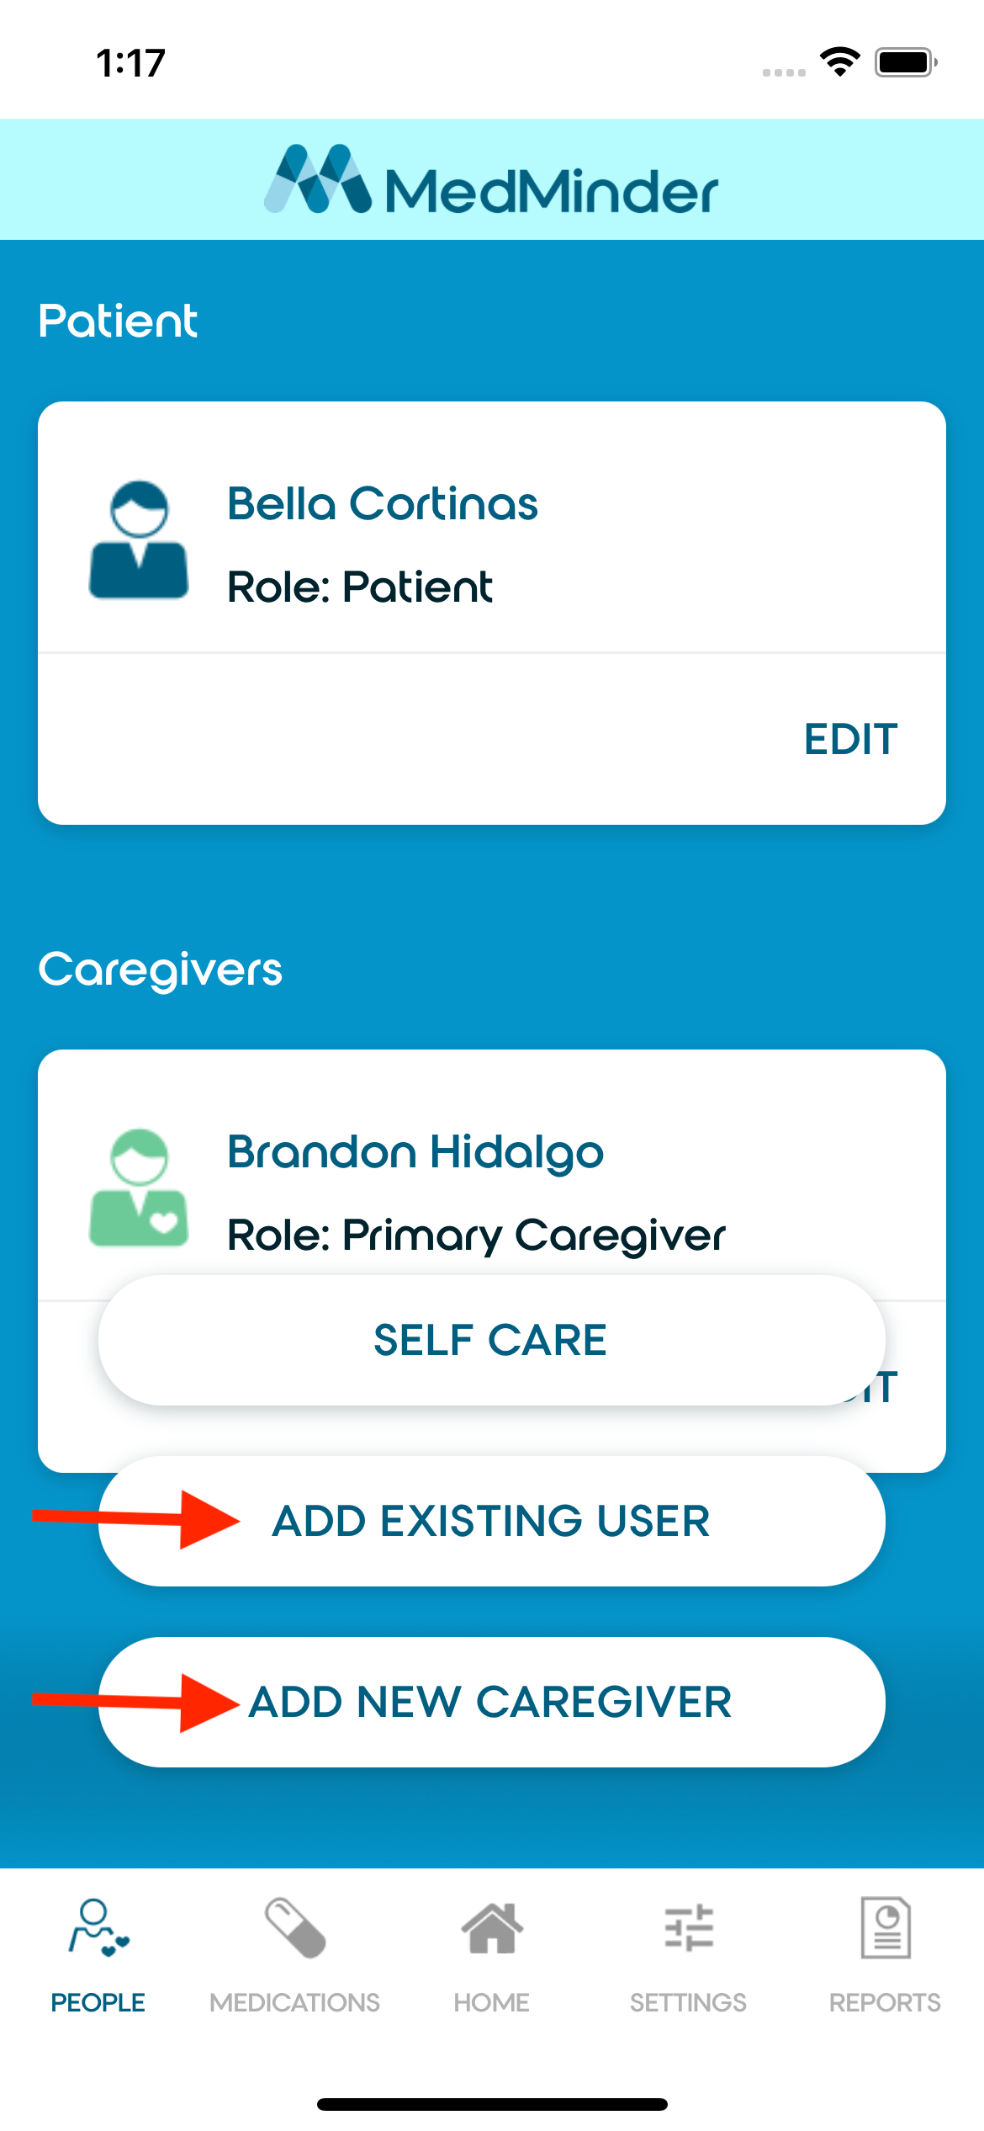

If adding a caregiver who already has an account with MedMinder, enter the caregiver’s email and press the search icon. Select the correct caregiver and complete the invitation form.

When adding a new caregiver to a patient account, the primary caregiver will have the option of transferring the primary caregiver role.

Once submitting the request to add a new caregiver, the new caregiver will receive a notification with the option to accept or decline the invitation to become a caregiver for the patient.

Transferring Care
The transfer care option assigns a caregiver as the primary caregiver over the patient. The caregiver must already be added as a caregiver for the patient. Refer to Adding Caregivers for information on how to add a caregiver to a patient.

Select the patient from the Patient List page and click the People tab. Press the “Add Caregiver” button and select “Transfer Care”. Select the caregiver who will become the new primary caregiver and submit the request.

Self-Care
The self-care option makes the patient their own primary caregiver. The patient must have an account registered with MedMinder. This option is found within the Add Caregiver menu.

Managing Medications
To manage medications, select the patient from the Patient List page and click on the “Medications” tab on the bottom of the screen.
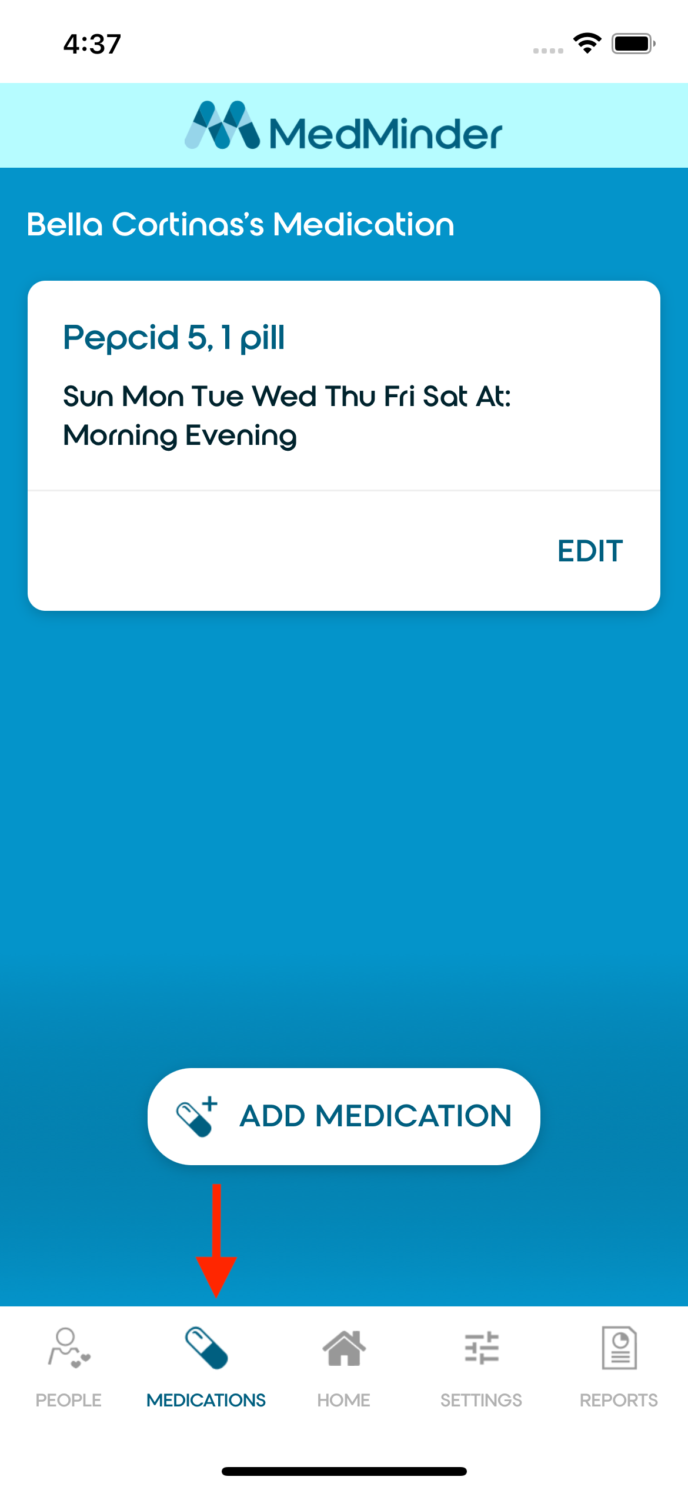

When adding a medication, provide the medication name, dosage information, day of week, and part of day. Existing medications can be edited by pressing the Edit button within the medication card.

If at least two medications exist, the user will have the option of deleting a medication. It is required that at least one medication is present.

Managing Dosage Schedule

The dosage schedule can be accessed in the settings tab under “Dosage Timespans”.

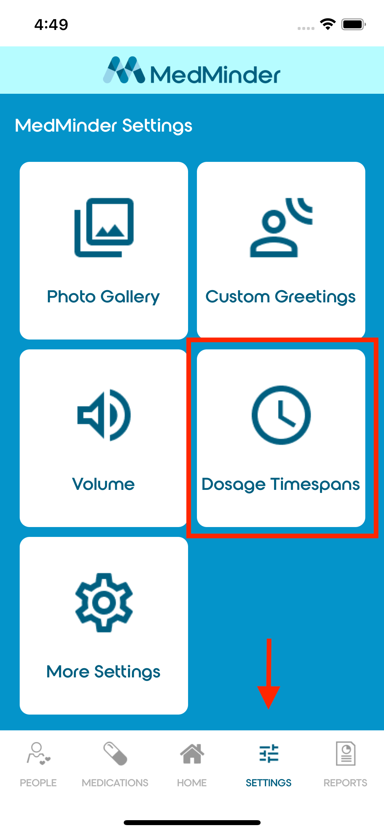

The Dosage Timespans settings page contains settings for Multiweek, alerts, and Time Spans. There is also a setting for “Taking out wrong Cup Tone”.

Select the Start Time for each Time Span applicable to the dosage schedule. Alert and notification times are based off the selected Start Time.

Once Dosage Timespan settings are configured, scroll to the bottom of the page, and click “Save” to ensure the settings are submitted.

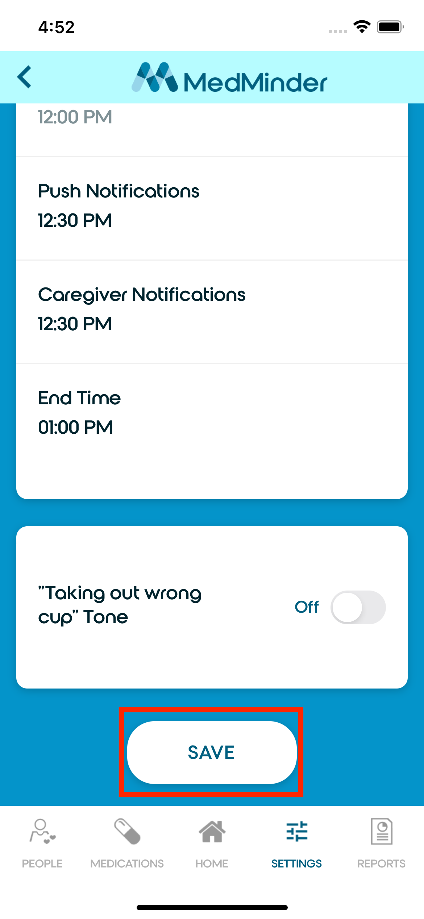

Device Settings

Registering a Device
Select the patient from the Patient List page and press the Settings tab at the bottom of the screen. If the patient already has a registered device, the user must deregister the patient’s device first before registering a new device. See Deregistering a Device.

Select the “Register Device” option within the settings page. Submit the device serial number.

Deregistering a Device
Select the patient from the Patient List page and press the Settings tab at the bottom of the screen. Click the “More Settings” option within the settings page. Scroll to the bottom of the page and press “Deregister Device”.

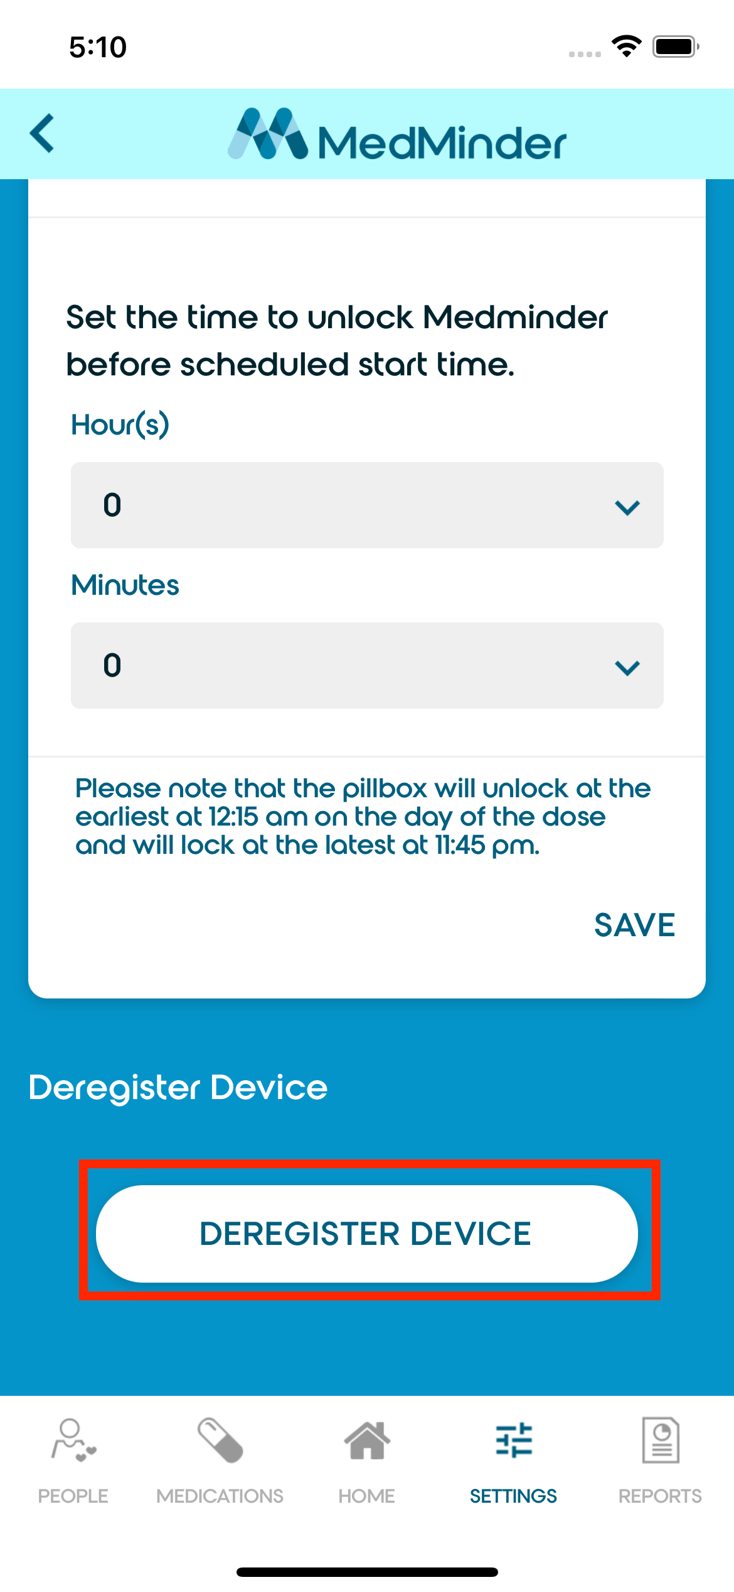

Other Settings
The MedMinder Mobile Application provides the following additional settings:

Photo Gallery
Enable or disable the Image Gallery feature. Upload photos straight from the mobile phone’s photo library (requires permission). Up to twelve custom images may be uploaded.

Custom Greetings
Configure Custom Greetings from the mobile phone. Use text-to-speech or record audio (requires permission).

Volume
Select the volume level for the Pill Dispenser.

Pin Code
Configure the pin code for the Pill Dispenser’s Settings menu.

Locking
Configure a locking schedule. Unlock compartments before the dosage start time. Relock compartments after the dosage end time.

